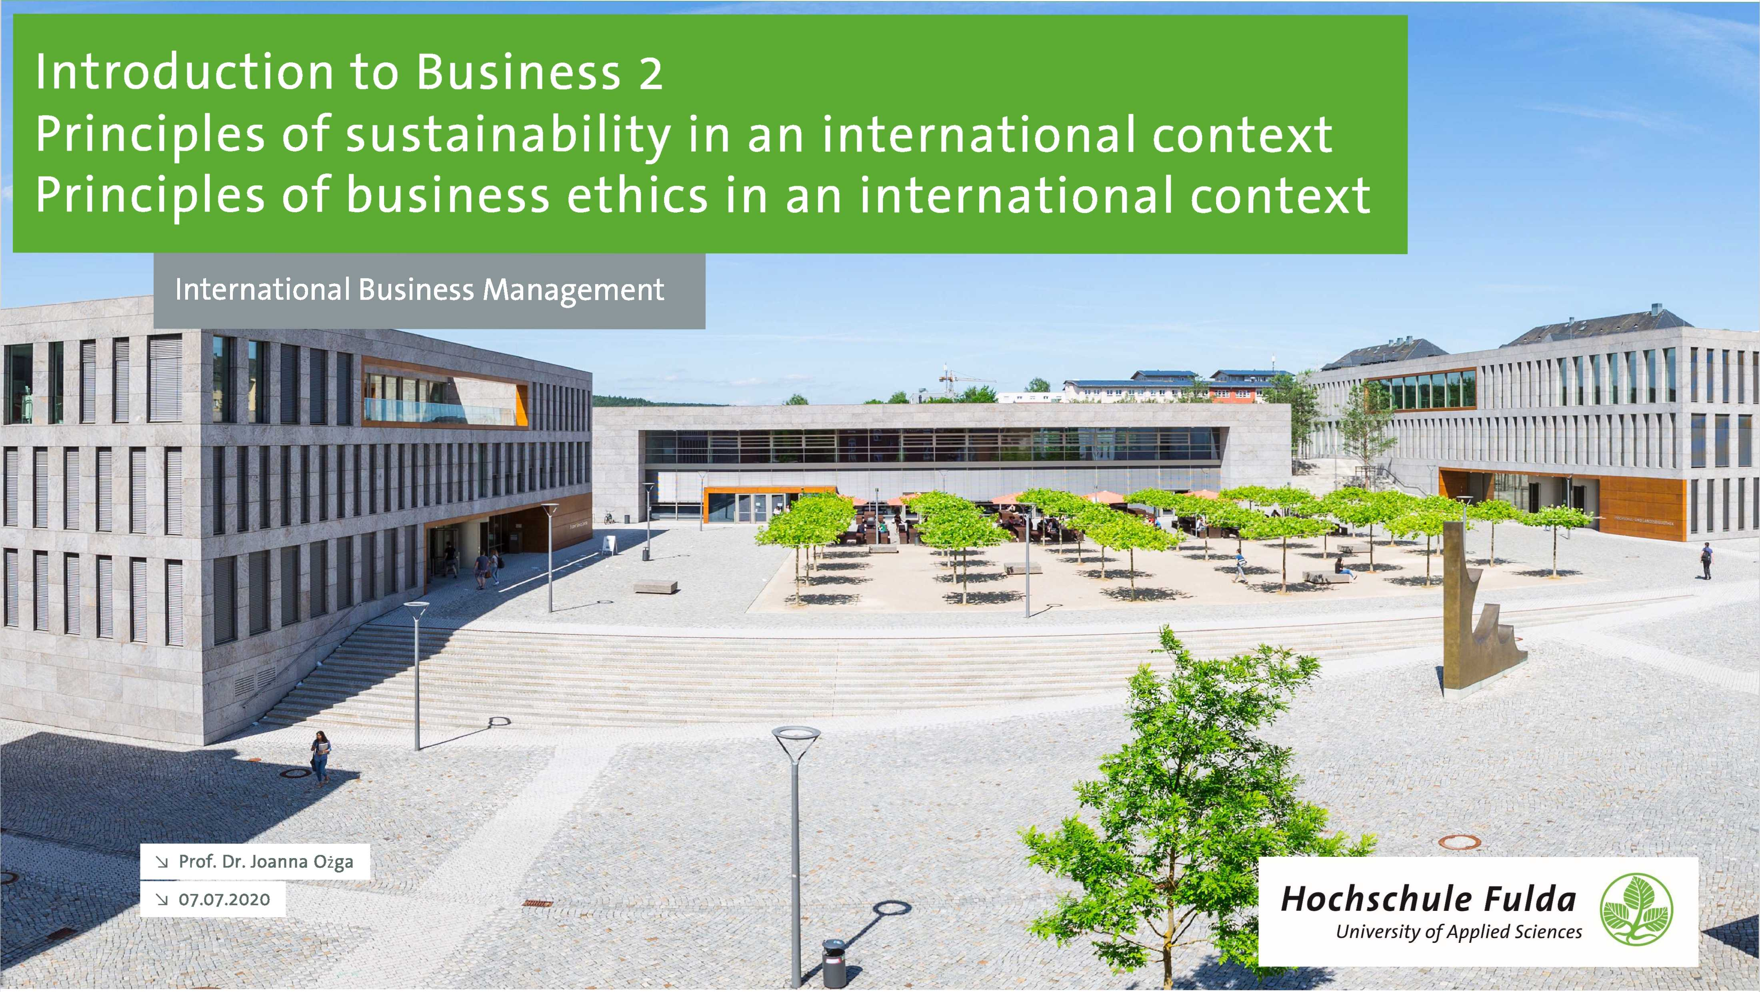

Recapitulation from the last week

\ Describe the effects of downsizing on organizational structures and employees. Analyze the behavioral implications of different organizational designs.

\ Link organizational structure with the strategy

Hochschule Fulda

University of Applied Sciences

Learning Objectives

\ Know what is constituted as corporate social responsibility (CSR)

Understand what is practiced as CSR

Understand the roles played by corporate codes of ethics

\ Appreciate different foundations for ethical behaviour

\ Grasp the delicate balance between principlesand profit

Hochschule Fulda

University of Applied Sciences

Introduction

\iThe risk society

\i One in which the life-threatening disasters that we might be subject to cannot be controlled within a specific territory (they spread)

\iCorporate social responsibility (CSR)

\i The explicit attempt by an organization to signal that it exceeds minimum legal obligations to stakeholders that are specified through regulation and corporate governance, often by extending the notion of stakeholders to be more inclusive

Hochschule Fulda

4 University of Applied Sciences

Stakeholder management

^Stakeholders

\i The standard definition of a stakeholder is any person with an interest in the activity of an organization

\i We might restrict this definition to those whom the organization affects with their activities, such as owners, investors, employees, trades unions that organize the employees, customers, consumer associations, regulators, suppliers, and citizens living in sufficient proximity to an organization's material presence to be affected by it

Hochschule Fulda

University of Applied Sciences

MNC Stakeholders

|  |  |  |
| --- | --- | --- |
| **Home Country /** | | **Host Country** |
| Owners | \ MNC // | Economy |
| Customers | Employees |
| Employees |  | Community |
| Unions |  | Host Government |
| Suppliers |  | Consumers |
| Distributors |  | Strategic Allies |
| Strategic Allies | **Society in General** | Suppliers |
| Community | Global Environment and Ecology | Distributors |
| Economy | Sustainable Resources |  |
| Government | Population's Standard of Living |  |

Source: Morschett et al. (2015), p. 302, adapted from Deresky 2014, p. 62.

Hochschule Fulda

University of Applied Sciences

Corporate greening

\i Corporate greening

\i A process that involves trying to adopt green principles and practices in as many facets of the business as it is possible to do so

\i Learning to be green involves

\i Lifelong learning

\i Critical thinking

\i Citizenship capabilities

\i Environmental literacy

\i Ecological wisdom

Hochschule Fulda

University of Applied Sciences

Corporate greening

\i Corporate 'green-wash?

\i Operating in a way that appears green but has a greater financial benefit for the organization than the environment

\i Governments can also be complicit in "green washing"

Hochschule Fulda

University of Applied Sciences

Doing CSR

\i Corporate codes of ethics

\i Moral guidelines or ethical *rules* for employees and suppliers

\i Enabling or coercive

\i Rules can work as ceremonial facades

\iGlobalization and CSR

\iClimate change: precautionary principle

\i Its legitimacy is highly contested

\i Climate science versus climate sceptics

Hochschule Fulda

University of Applied Sciences

Corporate Social Responsibility Pyramid

|  |  |  |
| --- | --- | --- |
| Be a Good Corporate Citizen | zPhilanK  / trophic X. / (“Being a Good\ Citizen") | Desired |
| Be Ethical | Ethical  ("Being Ethical") | X. Expected |
| Obey the Law / | Legal ("Obeying the Law") | X. Required |
| Be Profitable / | Economic ("Being Profitable") | X. Required |

Source: Morschett et al (2015), p. 302, Carroll 1991. ***Hochschule Fulda***

Doing CSR

\iThe circular and steady state economy

\i Growth, use and waste

\i De-growth as an movement and idea

\i Cradle-to-cradle-principle

\i <https://www.youtube.com/watch?v=fP8PRA-OajU>

<https://c2c-ev.de/podcast/> (in German)

11

**Hochschule Fulda**

University of Applied Sciences



Challenge of managing ethics

\ Ethics of sustainability

\1C0de of ethics

^Triple bottom line of people, planet and profit

Hochschule Fulda

12 University of Applied Sciences

Measures to Capture the Triple Bottom Line

|  |  |  |
| --- | --- | --- |
| Economic | Environmental | Social |
| sales, profits, ROI | pollutants emitted | health and safety record |
| taxes paid | carbon footprint | community impacts |
| monetary flows | recycling and reuse | human rights, privacy |
| jobs created | water and energy use | product responsibility |
| supplier relations | product impacts | employee relations |

Source: Morschett et al (2015), p. 301, adapted from Savitz/Weber 2014, p. 5.

**Hochschule Fulda**

University of Applied Sciences



CSR Management Model

Organising  
Identity

*Business Context*

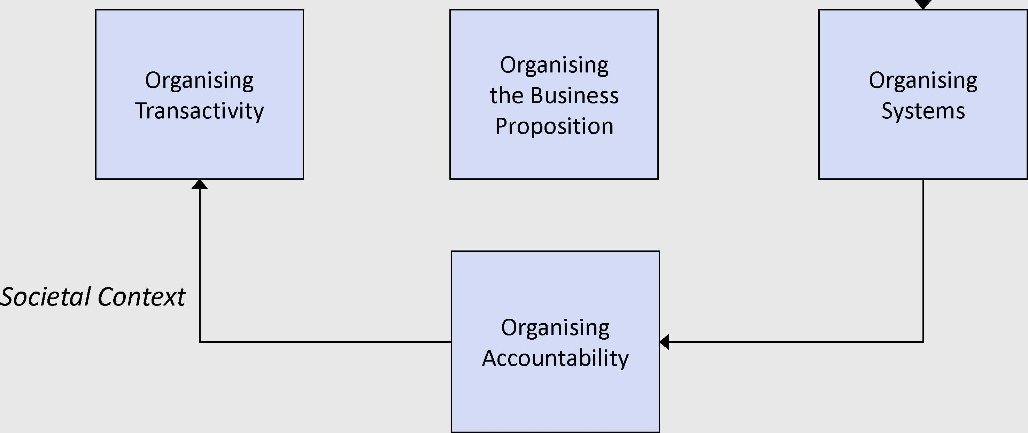

Source: Morschett et al. (2015), p. 303, Jonker/De Witte 2006, p. 5. **Hochschule Fulda**

1,1 1 University of Applied Sciences

Success factors of green learning

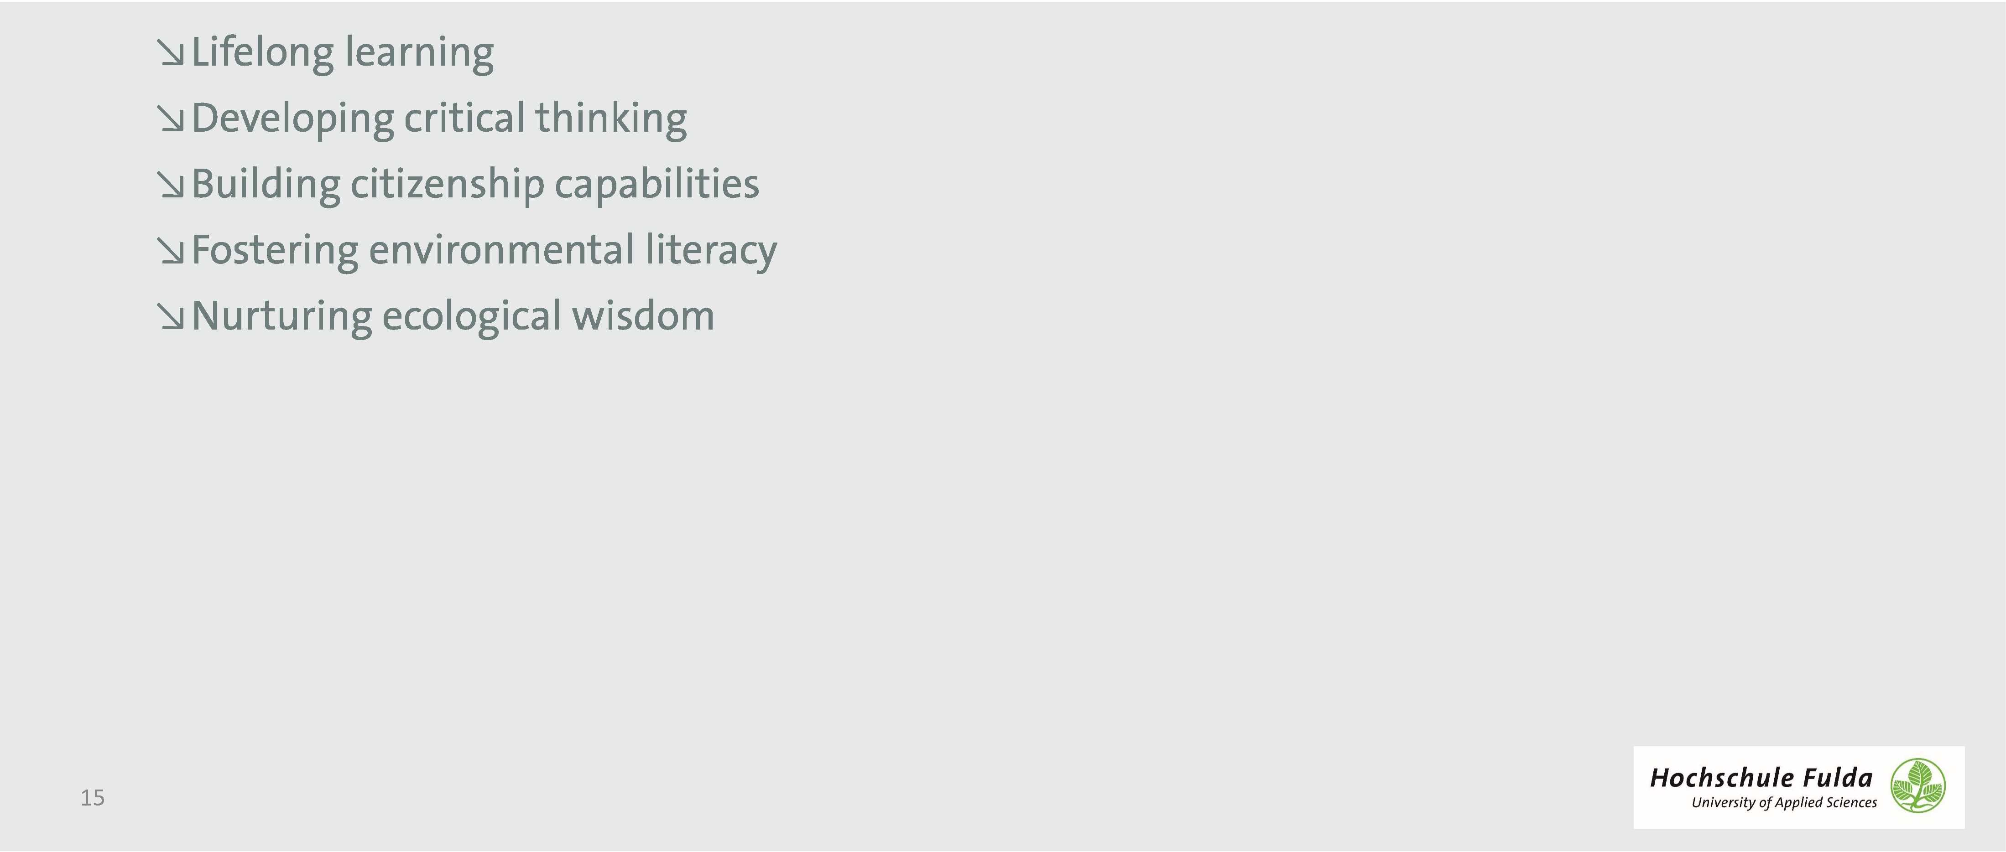

Approaches to ethics

\i Normative ethics

\i Seeks to establish means of judging whether business practices are right or wrong

\i Descriptive approach

\i Does not seek for normative guidelines that ought to be applied in practice, but rather monitor and describe what actually happens

Hochschule Fulda

1. University of Applied Sciences

Approaches to ethics

^Ethics as control

The use of codes

Normative integrity-based practice

\ Risk

\i Moral duty

\The business of ethics, and ethics of business

Hochschule Fulda

1. University of Applied Sciences

Approaches to ethics

^Ethics pays?

\ Aligning ethics and business practices provides competitive advantage

\ Being ethical does not run counter to business practices because it can also be about making profit

\ Business philanthropy

Ethics or marketing?

Behaving ethically means rigorously applying the rules of good management

Hochschule Fulda

1. University of Applied Sciences

Approaches to ethics

\i Ethics as individual responsibility

\i Responsibility of the individual, not the business

\i Unethical organizational behaviour due to "bad apples'within the organization

\i Ethics is a managerial moral task

\i Ethics and bureaucracy

Transformations of bureaucracies to entrepreneurial-like organizations opens room for member’s discretion

\i Bureaucracies preserve certain "ethical dignities' lost in market systems

Hochschule Fulda

1. University of Applied Sciences

